1. Create JSON file for the hub which looks like

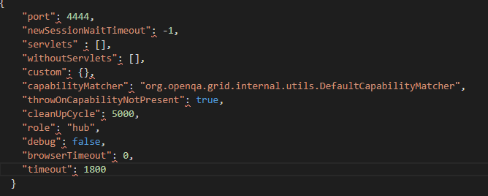

b.Type the below command in command prompt

**Java -jar selenium-server-standalone-3.141.59.jar -role hub -hubConfig myhub.json** and click on **Enter** button, which looks like

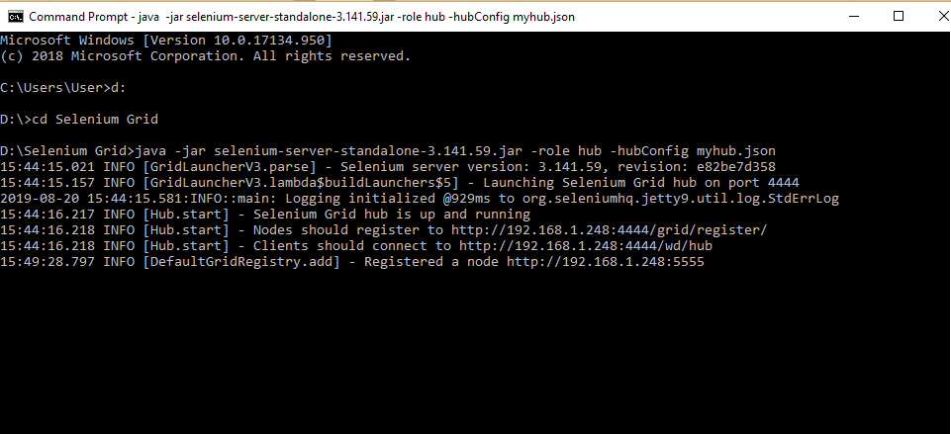

1. Open the Chrome browser
2. Enter URL as ‘http://localhost:4444/grid/console’ and click on enter
3. Grid console page is loaded as below

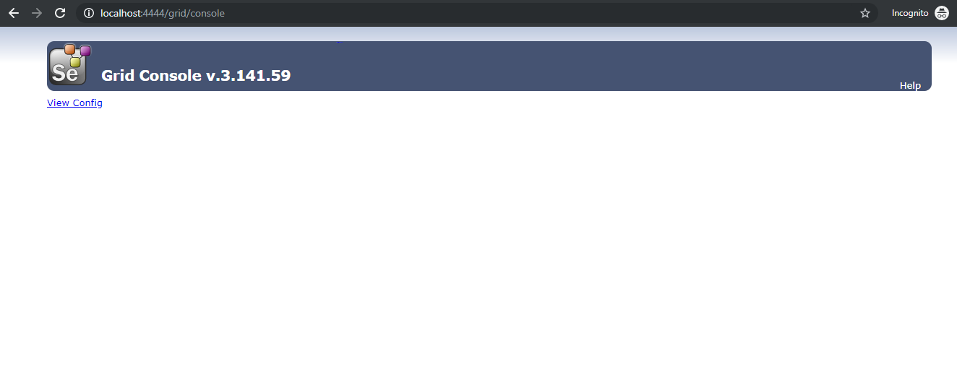

1. Once the Selenium Grid Hub using JSON is configured, the next step is to configure Selenium Grid nodes using JSON.
2. Create JSON file for node, which looks like:

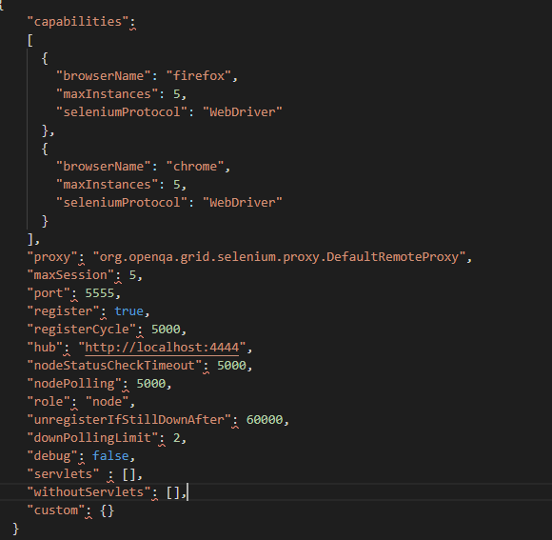

1. Save it in a folder with a valid name (example: mynode) in which we have saved Selenium standalone Server jar file
2. Open the new command prompt
3. Navigate to the folder structure where you have saved the Selenium standalone server jar file
4. Type the below command in command prompt

**java -Dwebdriver.gecko.driver="geckodriver.exe" - Dwebdriver.chrome.driver="chromedriver.exe" -jar selenium-server-standalone-3.141.59.jar -role node -nodeConfig mynodes.json**

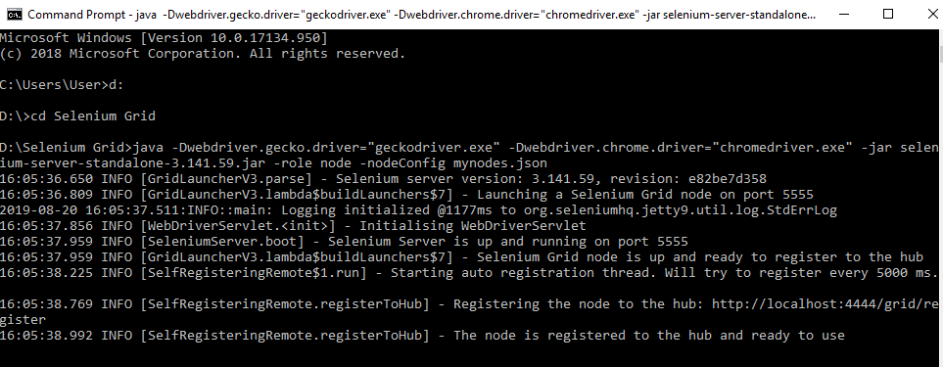

1. Open the browser
2. Enter URL as **http://localhost:4444/grid/console** and click on E**nter**
3. Grid console page is loaded, which shows **Browsers** by default

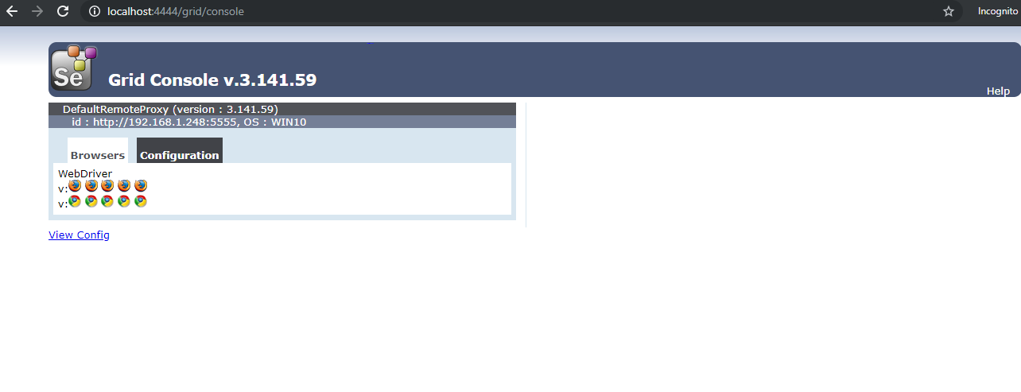

1. Click on **Configuration** which shows Configuration details

